**Software required** :Eclipse, JDK and Selenium Jar files

**Driver required** : Edge Web driver

**Script** : JavaScript

**Task 7: Date picker:**

**Step 1: Creating files:**

Open the eclipse and create a java project 🡪 Create Package under the project file 🡪 Create class file under the package. This step is common for all projects.

Importing the selenium jar files. Go to project file 🡪 right click on project file 🡪 select build path 🡪 library’s 🡪select class path 🡪 add external jars 🡪 select all selenium jar files 🡪 apply and close.

**Step 2: Launching the web driver:**

Download the preferred web driver and set the driver to launch the browser during execution of script. mention the driver location in string format in to the script to invoke web driver.

**Step 3: write the script for date picker to a web element using java script:**

Get one demo website to automate the date picker calendar by using get method. Write the code for pick the past and future date, month and year of the web calendar. refer the below code for pick the date.

package UsingOfWebElements;

import org.openqa.selenium.By;

import org.openqa.selenium.WebDriver;

import org.openqa.selenium.edge.EdgeDriver;

public class DatePicker {

public static void main(String[] args) {

System.setProperty("webdriver.edge.driver", "C:\\Users\\keerthiraja.sp\\Downloads\\edgedriver_win64\\msedgedriver.exe");

WebDriver driver =new EdgeDriver();

driver.manage().window().maximize();

driver.get("https://demo.automationtesting.in/Datepicker.html");

//below x path is refer the calendar icon

driver.findElement(By.xpath("/html/body/section/div[1]/div/div/form/div[2]/div[2]/img")).click();//clicking calendar icon

//choosing previous month year and date

for (int i= 12; i>=1; i--) {

//below x path is used to find the previous button and click.

//i=12 is referred as how many month and year we move the past and click 12 times previous button

driver.findElement(By.xpath("/html/body/div/div/a[1]")).click();

//Below x path is used to refer month and year column

String month=driver.findElement(By.xpath("/html/body/div/div/div/span")).getText();

// Below condition is month is equal to November then click the date

if(month.equals("November")){

driver.findElement(By.linkText("15")).click();

break;

}

}

//choosing future month year and date

for (int i= 12; i>=1; i--) {

//below x path is used to find the next button and click.

//i=12 is referred as how many month and year we move the future and click 12 times next button

driver.findElement(By.xpath("/html/body/div/div/a[2]")).click();

//Below x path is used to refer month and year column

String month=driver.findElement(By.xpath("/html/body/div/div/div/span")).getText();

// Below condition is month is equal to November then click the date

if(month.equals("November")){

driver.findElement(By.linkText("15")).click();

break;

}

}

}

}

**Output: (Output for select past year month and date)**

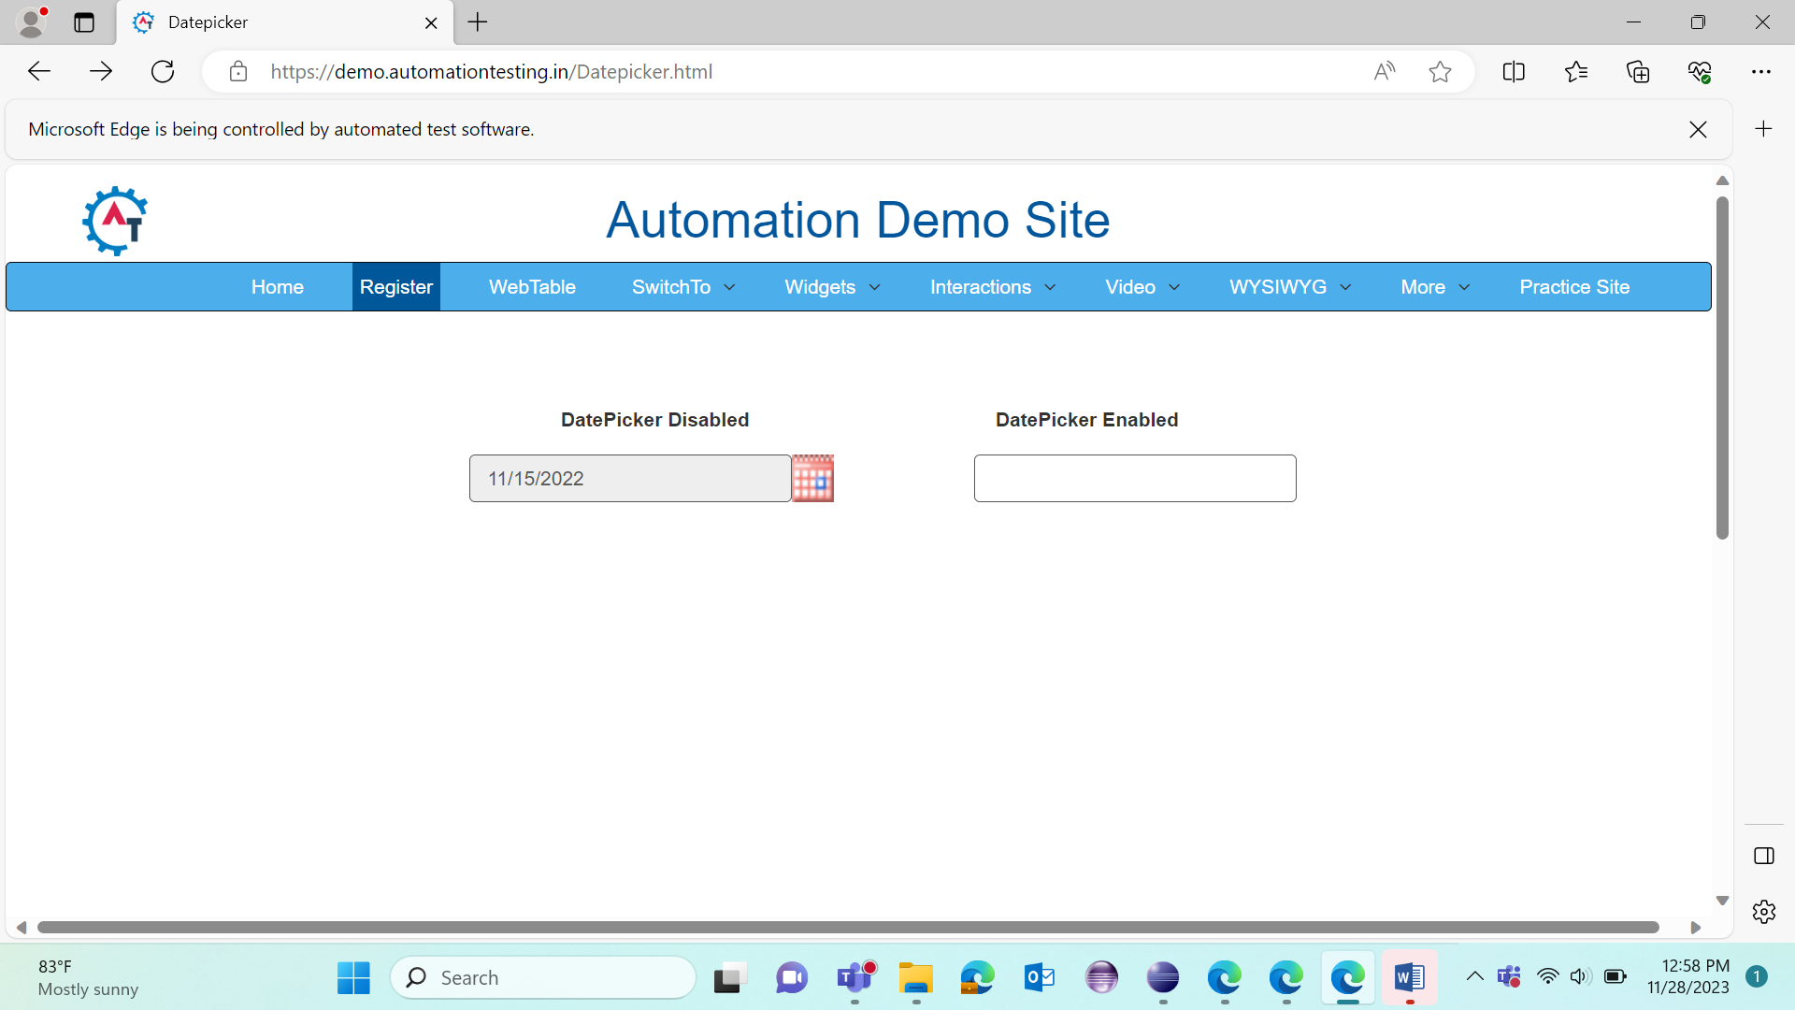

**Output: (Output for select future year month and date)**

